SOFTWARE ARCHITECTURE

Project number / Title | MT_ONE_0023 / miRFlow: A Novel Screening Tool for Endometrial Cancer

Version Control
Version | Description |  | Date  (dd Mmm yyyy) | Author
v0.01 | First draft for circulation |  | 27/03/2026 | Samin Yasar
v1.01
APPROVAL
Name | Organisation | Position |  | Signature / Date
PI’s name | Imperial College | Principal Investigator

CONTENTS
References 3
1. INTRODUCTION 5
1.1 Scope 5
1.2 Definitions, Abbreviations and Conventions 5
2. ARCHITECTURE OVERVIEW 5
3. DEVICE ARCHITECTURE 6
3.1 Architecture rationale 6
Performance 6
Safety 7
Usability 7
SOUP Integration 7
Other Requirements 7
3.2 Functional Requirements Table 7
3.3 Hardware Components 7
3.3.1 Hardware Component 1 7
3.4 Software Components 7
3.4.1 Software Component 1 7
3.5 SOUP Items 7
3.5.1 SOUP Item 1 7
4. DIAGRAM 8
5. WORKFLOW 8
5.1 Work Flow 1 8
5.2 Necessary Segregation (Class C only) 8

References
Ref/ID | Title
IEC 62304:2006 | Medical device software — Software life cycle processes
BS EN 62304: 2006 + A1 2015 | Medical device software — Software life cycle processes
FDA Guidance | Off the shelf Software use in Medical Devices

Ref/ID | Title
QSP005 | Risk Management
QSP019 | Software LifeCycle processes inc Design and Development
 | Design Brief, Meeting minutes, Interface overview

INTRODUCTION

Scope
This document describes the software architecture of the miRFlow system: an independent analytical platform developed to support the miRFlow diagnostic assay. The aim of the software is to process, analyse, and visualise flow cytometry (fc) data captured by the diagnostic assay for the detection of microRNA (miRNA) biomarkers associated with endometrial cancer.
The purpose of this document is to define the structural organisation of the software, including its constituent modules, data flow, interfaces, and interactions with external systems. The architecture describes how raw Flow Cytometry Standard (.fcs) data is transformed through a series of computational stages into structured outputs and diagnostic metrics.
The software backend comprises of a modular analytical pipeline managing data ingestion, signal transformation, gating, bead classification, probabilistic clustering, and result generation. In addition, the architecture outlines planned components, including a graphical user interface (GUI) and a machine learning (ML)-based module for image-derived event weighting, which will be integrated in later stages of development.

Definitions, Abbreviations and Conventions

Terminology/ Abbreviations/ Acronyms/ Definitions | Meaning
AWS | Amazon Web Services
PHI | Protected Health Information
BLE | Bluetooth Low Energy
VCS | Version Control System
CPU | Central Processing Unit
OS | Operating System
PC | Personal Computer
USB | Universal Serial Bus
RCR | Risk Control Requirement (cf risk analysis)
SRS | Software Requirement Specification
FC | Flow Cytometry
FCS | Flow Cytometry Standard File
MMB | Magnetic Micro-Bead (Size Signal)
DG | Dragon Green-Bead (Fluorescence Signal)
GMM | Gaussian Mixture Model
ROI | Region of Interest
ML | Machine Learning
FSC-H | Forward Scatter Height (proxy for particle size in flow cytometry)
B525-H / FL1-H | Fluorescence detection channel for green emission (used for DG signal detection)
KDE | Kernel Density Estimation (used for smooth density modelling of signals)
JSON | JavaScript Object Notation (used for structured configuration and output files)
GUI | Graphical User Interface (planned frontend for user interaction)
ROI Bounds | Lower and upper limits defining the region of interest for analysis

ARCHITECTURE OVERVIEW
The miRFlow software architecture is designed to transform raw flow cytometry data into structured analytical outputs and clinically interpretable metrics through a modular computational pipeline. The architecture defines the organisation of software components, data flow between modules, and interactions with external systems.
The system is implemented as a standalone analytical software platform that operates in a standard computing environment (e.g., personal computer). It processes Flow Cytometry Standard (.fcs) files generated by external flow cytometers and does not directly interface with or control the hardware used for data acquisition.
The primary users of the system are researchers and laboratory personnel during development. In later stages of the project, the software is intended to support clinical users through a planned graphical user interface (GUI), which will enable simplified interaction with the analysis pipeline.
The software operates within a laboratory data analysis environment, where .fcs files are exported from flow cytometers and provided as input to the system. The architecture is designed to be robust to variations in data structure and instrument configurations through dynamic channel detection and standardised signal transformation.
The main implemented functional components of the system include:
- Module 1 – FCS Data Visualiser: Ingestion of raw .fcs files, automatic channel detection, signal transformation (logicle/asinh), and generation of per-sample density, size, & fluorescence visualisations.
- Module 1.5 – FCS Output Organiser: Aggregation and organisation of visual outputs into structured overview panels for batch-level inspection and quality control.
- Module 2 – Global Gating: Control-derived signal standardisation using KDE-based analysis to define global regions of interest (ROI) for size and fluorescence.
- Module 3 – MMB Boundaries Extractor: Deterministic classification of bead populations (MMB-3, MMB-6, MMB-8) using FSC-derived thresholds obtained from control data.
- Module 4 – GMM Probabilistic Clustering: Probabilistic classification of fluorescence signals within each bead population using Gaussian Mixture Models (GMM), generating labelled visualisations, structured JSON outputs, and aggregated CSV summaries.
These modules form Branch A (Flow Cytometry-based signal segmentation), which represents the currently implemented analytical pathway. Data flows sequentially through these modules, with outputs from each stage serving as inputs to subsequent components, ensuring a traceable and reproducible analysis pipeline.
The architecture also includes a planned secondary pathway, Branch B (Image-based event weighting), which will integrate confocal microscopy-derived features such as fluorescence intensity distributions and spatial binding heterogeneity. This branch will support future machine learning (ML)-based multi-modal analysis, enhancing the robustness and accuracy of event classification. This functionality is currently under development.
The outputs from both branches will be integrated within a final scoring stage, where flow cytometry-derived signals and image-derived metrics are combined to compute clinically relevant risk metrics based on miRNA expression profiles.
The system interacts with external components only by receiving input files and generating output files, rather than directly controlling or communicating with hardware devices. Input data is provided as .fcs files generated by flow cytometry instruments, and outputs are generated as structured files (JSON, CSV) and visualisations (PNG) for interpretation and further analysis.
A detailed representation of the system architecture, module interactions, and data flow is provided in Section 4 (Architecture Diagram).

DEVICE ARCHITECTURE

Architecture rationale
The miRFlow software architecture is designed as a modular, sequential analytical pipeline that processes flow cytometry data through a series of well-defined stages. This modular architecture was selected to ensure reproducibility, robustness, and traceability of the analytical workflow while supporting iterative development and validation using experimental datasets. The separation of deterministic and probabilistic processing stages allows improved interpretability of results and reduces the complexity of individual computational components.

Performance
The architecture is designed to ensure efficient processing of flow cytometry datasets while maintaining scalability across multiple samples.
Performance is supported through:
- Sequential modular processing, allowing each module to operate independently and efficiently on subsets of the data.
- Use of numerical libraries (NumPy, Pandas) for efficient data handling and transformation.
- Application of Gaussian Mixture Models (GMM) on filtered regions of interest (ROI), reducing computational overhead by excluding irrelevant events.
- Use of precomputed control-derived parameters (global gating windows and bead thresholds), avoiding repeated recalculation during patient-level analysis.
This design ensures that computationally intensive operations are restricted to relevant data regions, improving runtime efficiency while maintaining analytical accuracy.

Safety
Software-related risks in the miRFlow system primarily relate to incorrect classification of events, which could lead to inaccurate interpretation of assay results.
The architecture mitigates these risks through the following design features:
- Control-derived global gating (Module 2): Ensures that only biologically relevant signal regions are analysed, reducing the likelihood of noise-driven misclassification.
- Deterministic bead segmentation (Module 3): Separates bead populations prior to clustering, preventing incorrect mixing of size-dependent signals.
- Probabilistic classification using GMM (Module 4): Incorporates uncertainty through posterior probabilities rather than relying solely on hard thresholds.
- Fallback mechanisms: In case logicle transformation fails, another commonly used approach called the asinh transformation will be used across all the modules. Furthermore, for low-event datasets in module 4, two components are used instead of three whilst clustering, ensuring robustness under varying data conditions.
- Quality control through visual outputs (Modules 1 and 1.5): Enables manual inspection of distributions and gating behaviour to help detect sources of errors and anomalies.
These architectural decisions reduce the likelihood of systematic errors and support safe interpretation of analytical outputs.

Usability
The architecture supports usability through clear separation of processing stages and generation of outputs.
Key usability considerations include:
- FCS visualisations (Module 1): Provides immediate graphical representation of data distributions for user understanding.
- Batch-level overview generation (Module 1.5): Enables efficient inspection of multiple datasets through aggregated visual panels.
- Structured outputs (JSON and CSV): Facilitate downstream analysis and integration with other tools.
- Planned GUI integration: Future development of a graphical user interface will allow users to upload data, execute the pipeline, and interpret results without requiring direct interaction with the underlying source code.
These features ensure that both technical and non-technical users can interpret system outputs effectively.

SOUP Integration
The miRFlow software relies on several third-party libraries (Software of Unknown Provenance, SOUP) for data processing, statistical modelling, and visualisation.
These include:
- NumPy and Pandas for numerical computation and data handling.
- SciPy for kernel density estimation (KDE) and signal processing.
- scikit-learn for Gaussian Mixture Model (GMM) implementation.
- Matplotlib for visualisation.
- fcsparser and flowutils for reading .fcs files and performing logicle transformations.
The architecture is designed such that these dependencies are:
- encapsulated within specific modules, limiting their impact on the overall system.
- replaceable if required, reducing dependency risk.
- version-controlled and documented, ensuring reproducibility.
Fallback mechanisms (e.g., asinh transformation in place of logicle) are implemented to reduce reliance on specific libraries where possible.

Other Requirements
Reproducibility and Traceability: The architecture ensures reproducibility through:
- Use of control-derived parameters stored in JSON files.
- Version-controlled code and configuration files.
- Structured outputs that allow full traceability from input data to results.
Data Integrity and Storage: The system processes locally stored .fcs files and generates structured outputs without modifying original input data. Outputs are stored in organised directories to maintain data integrity and auditability.
Security and Data Privacy: At the current stage, the software operates in a local, offline environment, reducing exposure to network-based security risks. No direct handling of identifiable patient data is implemented within the system.
Future clinical deployment may require additional safeguards to ensure compliance with data protection regulations.
Availability and Reliability: The modular architecture improves reliability by:
- Isolating failures within individual modules.
- Allowing debugging and validation at each stage.
- Enabling partial execution of the pipeline without requiring full system reprocessing.
Scalability: The architecture supports scalability through:
- Batch processing of multiple .fcs files.
- Modular execution of pipeline stages.
- Potential extension to multi-modal analysis (Branch B).

Functional Requirements Table

Functional Requirement ID | Functional Requirement Description | Implementing Software Component
FR1 | The software shall ingest and process raw flow cytometry .fcs files from control and patient samples | Module 1 – FCS Data Visualiser
FR2 | The software shall automatically detect relevant signal channels (FSC-H and fluorescence channels) across different datasets | Module 1 – FCS Data Visualiser
FR3 | The software shall apply signal transformation (logicle or fallback to asinh) to standardise flow cytometry data | Module 1 – FCS Data Visualiser
FR4 | The software shall generate visual representations of size and fluorescence distributions for exploratory analysis | Module 1 – FCS Data Visualiser
FR5 | The software shall aggregate and organise generated visual outputs for batch-level inspection | Module 1.5 – FCS Output Organiser
FR6 | The software shall derive global signal gating boundaries using control datasets | Module 2 – Global Gating
FR7 | The software shall define a region of interest (ROI) for analysis based on size and fluorescence thresholds | Module 2 – Global Gating
FR8 | The software shall determine deterministic bead size boundaries (MMB-3, MMB-6, MMB-8) using FSC-H based analysis | Module 3 – MMB Boundaries Extractor
FR9 | The software shall classify events into bead populations based on FSC-H derived thresholds | Module 3 – MMB Boundaries Extractor
FR10 | The software shall perform probabilistic clustering of fluorescence signals within each bead population | Module 4 – GMM Probabilistic Clustering
FR11 | The software shall assign events into binding states (e.g., only, sandwich, multi-binding) using statistical modelling | Module 4 – GMM Probabilistic Clustering
FR12 | The software shall generate structured outputs including JSON summaries and aggregated CSV files for downstream analysis | Module 4 – GMM Probabilistic Clustering
FR13 | The software shall generate labelled visual outputs illustrating clustering results and gating boundaries | Module 4 – GMM Probabilistic Clustering
FR14 | The software shall support integration of additional data modalities (e.g., confocal imaging) for future analysis | Planned Future extension / Branch B (Module 5)
FR15 | The software shall be accessed through an easy to navigate Graphical User Interface (GUI), simplifying the steps needed to achieve desired outcomes | Planned UX interface for lab technicians (Module 6)

Hardware Components
The current miRFlow software architecture operates on a standard personal computer (PC) workstation and interacts with external laboratory hardware through file-based data exchange. The software does not directly control acquisition hardware and does not require embedded processing hardware, networked medical devices, or cloud-hosted infrastructure at the current stage of development.
The principal hardware components relevant to the software architecture are:
- Flow Cytometer: An external laboratory instrument used to acquire raw assay data. The instrument exports data in Flow Cytometry Standard (.fcs) format, which is subsequently provided to the miRFlow software for analysis.
- Workstation / PC: The computing platform on which the miRFlow software modules are executed. This device is responsible for data ingestion, signal transformation, gating, clustering, visualisation, and generation of structured output files.
- Confocal Microscopy System [planned future hardware component]: An external imaging platform that may provide image-derived fluorescence and spatial binding metrics for the planned Branch B image-based event weighting workflow.
The interaction between these components is based on offline data transfer rather than direct device control. The flow cytometer generates .fcs files externally, and these files are then loaded into the workstation for processing by the miRFlow software. Similarly, any future confocal microscopy inputs would be transferred to the workstation as exported data for downstream analysis.
At the current stage of development, the architecture does not depend on continuous network communication, remote servers, or direct instrument-to-software communication interfaces. This simplifies deployment and reduces architectural complexity, as the software operates as a local analytical platform.

Hardware Component 1
Describe each component. For class C, the description must contain the identification, software components received, technical characteristics, network hardware interfaces.

Software Components
The miRFlow software is structured as a modular analytical pipeline, where each software component performs a distinct stage of data processing. The architecture is designed to ensure clear separation of responsibilities, reproducibility of results, and traceable data flow between components.
The software is implemented in Python (3.x) and operates in a standard computing environment running a compatible operating system (e.g., Windows or macOS). The system relies on a set of scientific computing libraries for data processing, statistical modelling, and visualisation (see section 3.5).
The software components interact through a sequential data pipeline, where outputs from each module serve as inputs to subsequent modules. The primary data flow is as follows:
.fcs input
↓
Module 1 → visualisation + transformed data
↓
Module 1.5 → organised visual summaries
↓
Module 2 → global gating parameters
↓
Module 3 → bead classification thresholds
↓
Module 4 → clustering + final outputs (JSON, CSV, PNG)
Modules communicate using:
- in-memory data structures during execution
- structured configuration files (JSON) for parameter transfer
- file-based outputs for traceability and reproducibility
Module 1 – FCS Data Visualiser
This component is responsible for:
- ingestion of raw .fcs files
- automatic detection of relevant signal channels (FSC-H and fluorescence channels)
- application of signal transformation (logicle or asinh fallback)
- generation of per-sample visualisations of size and fluorescence distributions
This module establishes the preprocessing backbone of the system and ensures that input data is standardised for downstream analysis.
Module 1.5 – FCS Output Organiser
This component aggregates visual outputs generated by Module 1 into structured overview panels.
Its functions include:
- collection of individual .png outputs
- organisation into grouped categories (e.g., MMB/DG, size/fluorescence distributions)
- generation of consolidated overview visualisations for batch-level inspection
This module supports quality control but does not contribute directly to analytical decision-making.
Module 2 – Global Gating
This component performs control-derived signal standardisation.
Its functions include:
- application of kernel density estimation (KDE) to model signal distributions
- derivation of global gating boundaries for size (FSC-H) and fluorescence (B525-H) signals
- definition of a region of interest (ROI) for downstream analysis
- generation of configuration files (JSON) containing gating parameters
This module ensures consistent signal interpretation across datasets.
Module 3 – MMB Boundaries Extractor
This component performs deterministic bead classification based on size.
Its functions include:
- extraction of FSC-based size distributions from control datasets
- derivation of boundaries separating bead populations (MMB-3, MMB-6, MMB-8)
- generation of configuration files (JSON) containing bead classification thresholds
This module enables structured segmentation of events prior to clustering.
Module 4 – GMM Probabilistic Clustering
This component performs probabilistic classification of fluorescence signals.
Its functions include:
- application of region-of-interest gating using Module 2 outputs
- assignment of bead populations using Module 3 thresholds
- fitting of Gaussian Mixture Models (GMM) to fluorescence data within each bead population
- classification of events into binding states (e.g., only, sandwich, multi-binding)
- generation of outputs including labelled visualisations, JSON summaries, and aggregated CSV results
This module represents the core analytical engine of the system.
Planned Component – Image-Based Event Weighting (Branch B)
A future extension of the architecture will incorporate an additional component for integrating confocal microscopy-derived data.
This component is expected to:
- process image-derived fluorescence and spatial binding metrics
- apply machine learning (ML) techniques to assign weights to detected events
- integrate with flow cytometry-derived outputs to improve classification robustness
This component is currently under development and is not part of the implemented pipeline.
Planned Component – Graphical User Interface (GUI)
A graphical user interface is planned to provide user-friendly interaction with the software.
This component will:
- allow users to upload .fcs files
- trigger execution of the analysis pipeline
- display visual outputs and diagnostic summaries
- enable export of results

Software Component 1

SOUP Items
The miRFlow software relies on several third-party software libraries (Software of Unknown Provenance, SOUP) to support data processing, statistical modelling, and visualisation. These components are integrated into the system as external dependencies and are required for the correct operation of the analytical pipeline.
The SOUP items used in the system are listed below:

Software | Version | Origin | Function within miRFlow
NumPy | 1.26.0 | NumPy Developers | Numerical computation and array operations
Pandas | 2.0.3 | Pandas Developers | Data manipulation and structured data handling
scikit-learn | 1.3.0 | Scikit-learn Developers | Gaussian Mixture Model (GMM) implementation for probabilistic clustering
Matplotlib | 3.8.0 | Matplotlib Developers | Generation of visual outputs and plots
fcsparser | 0.2.5 | Open-source project | Reading and parsing .fcs flow cytometry files
flowutils | 1.0.3 | Open-source project | Logicle transformation for flow cytometry signal processing

Functional and Performance Requirements
Each SOUP component is used for a specific function within the software architecture:
- NumPy and Pandas provide efficient handling of large datasets and support vectorised operations.
- scikit-learn enables probabilistic modelling of fluorescence distributions through Gaussian Mixture Models.
- Matplotlib supports generation of diagnostic and quality control visualisations.
- fcsparser enables ingestion of .fcs files from flow cytometry instruments.
- flowutils supports logicle transformation of flow cytometry signals.
These libraries are required to ensure that the system performs data processing, modelling, and visualisation tasks efficiently and consistently.
Integration and Interfaces
SOUP components are integrated directly into the Python-based software modules through standard import mechanisms.
Integration characteristics include:
- direct use within specific modules (e.g., scikit-learn within Module 4, flowutils within Modules 1–2)
- encapsulation within modular functions, limiting cross-module dependency
- use of structured data formats (NumPy arrays, Pandas DataFrames) for internal data exchange
This integration approach ensures that SOUP components are contained within defined parts of the architecture, reducing the impact of potential changes or failures.
Supporting System Requirements
The correct operation of SOUP components requires:
- a compatible Python 3.x runtime environment
- a supported operating system (e.g., Windows or macOS)
- sufficient computational resources (CPU and memory) to process flow cytometry datasets
All SOUP dependencies are installed and managed within the development environment and will be documented in the project repository (e.g., via a SOUP Requirements.txt file).
Documentation
Documentation for SOUP components is available through their respective official sources and repositories. These include:
- official library documentation: NumPy, Pandas, scikit-learn
- open-source repositories for specialised libraries: fcsparser, flowutils
These sources provide information on usage, limitations, and known issues relevant to the integration of these components within the miRFlow system.

SOUP Item 1
Describe the SOUP items (identification, version, origin)
Specify the functional and performance requirement for the SOUP item that are necessary for the intended use (which SOUP functions are used). Include any interfaces and integration method. Identify any documentation required for COTS items.
Specify the system hardware and software necessary to support the proper operation of the SOUP item.
List any known bugs for COTS items. These should be reviewed to assess whether they can affect the user and user/patient safety (the review should be documented as a risk review that is referenced here, and refer to the software FMEA or risk analysis to manage those as part of the project risk management.

DIAGRAM
The architecture diagram below illustrates the modular structure of the miRFlow system, including the implemented flow cytometry analysis pipeline (Branch A), the planned image-based machine learning pipeline (Branch B), and their integration within a unified scoring module. The system culminates in a graphical user interface (GUI) designed to support clinical interpretation of results.

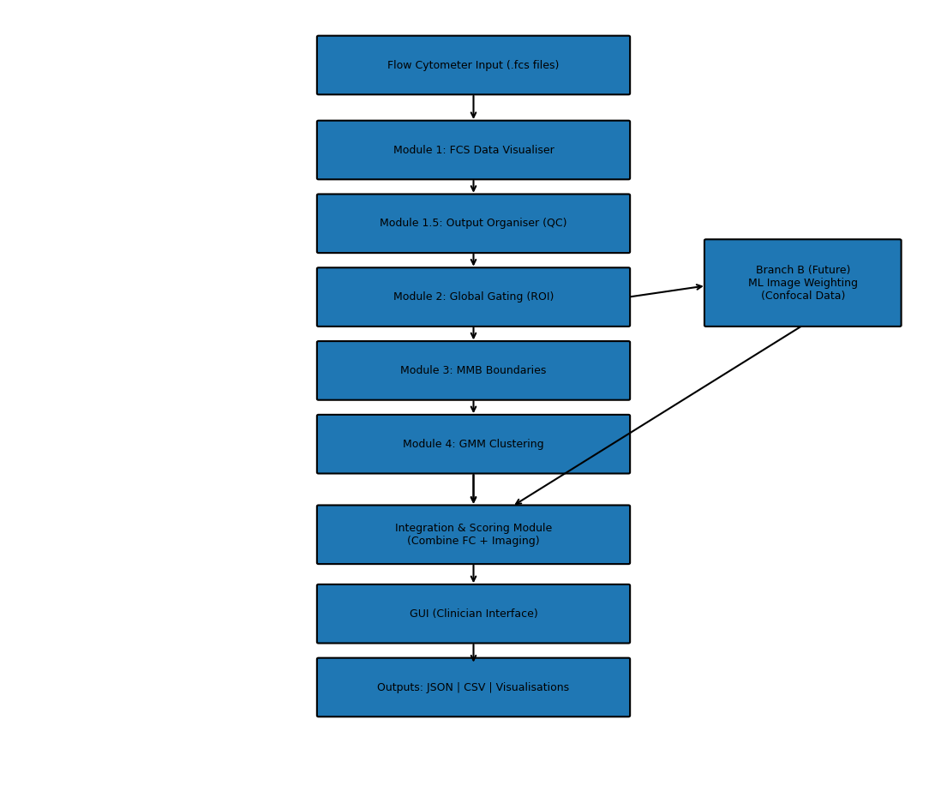

WORKFLOW

Work Flow 1
The miRFlow software follows a unified workflow that transforms raw assay data into structured analytical outputs and clinically interpretable metrics through a sequence of modular processing steps.
The workflow begins with data acquisition, where raw Flow Cytometry Standard (.fcs) files generated from control and patient samples are exported from the flow cytometer and provided to the software as input. In future development stages, the system may also receive image-derived data from confocal microscopy to support the planned machine learning (ML)-based Branch B workflow.
The first implemented processing stage is Module 1 – FCS Data Visualiser, which ingests the .fcs files, automatically detects the relevant size and fluorescence channels, applies signal transformation (logicle or asinh fallback), and generates visual representations of the raw data. This stage establishes a reproducible preprocessing layer and enables initial inspection of signal distributions.
The visual outputs generated in Module 1 are then passed to Module 1.5 – FCS Output Organiser, which groups related plots and produces overview panels for batch-level quality control and inspection. This supports rapid visual assessment of multiple datasets without affecting the analytical outputs directly.
Following visualisation, Module 2 – Global Gating processes control-derived datasets to define standardised signal boundaries for subsequent analysis. This module applies kernel density estimation (KDE) to derive global gating windows for size and fluorescence and exports these as structured JSON configuration files. These windows define the region of interest (ROI) used in downstream analysis.
The workflow then proceeds to Module 3 – MMB Boundaries Extractor, which analyses size distributions from MMB control datasets to derive deterministic FSC-based thresholds separating bead populations (MMB-3, MMB-6, and MMB-8). These thresholds are also exported as structured JSON configuration files for use in downstream classification.
In Module 4 – GMM Probabilistic Clustering, patient-level .fcs data is processed using the gating parameters from Module 2 and bead thresholds from Module 3. Events are first restricted to the defined ROI and assigned to bead populations based on deterministic FSC boundaries. Within each bead population, Gaussian Mixture Models (GMM) are then fitted to fluorescence distributions to classify events into bead-binding states such as only, sandwich, and multi-binding. This module generates labelled visualisations, structured JSON summaries, and aggregated CSV outputs.
In the planned future architecture, outputs from the implemented flow cytometry pathway (Branch A) will be combined with image-derived metrics from the planned Branch B – Image-based Event Weighting workflow. These two branches will converge within an Integration and Scoring stage, where flow cytometry-derived cluster information and imaging-derived weighting metrics are combined to compute final event-level or sample-level risk metrics.
The final stage of the intended workflow is a graphical user interface (GUI), which will allow end users, such as clinicians or laboratory staff, to load assay data, execute the analytical pipeline, review processed outputs, and interpret clinically relevant results in a simplified and user-friendly manner.
Overall, the workflow ensures that the system progresses from raw experimental input to increasingly refined and structured outputs in a traceable, modular, and reproducible manner.

Necessary Segregation (Class C only)
Specify the segregation necessary for risk control and define how the team will ensure that such segregation is effective.

